Street Smart for ArcMap User Manual

# Index

Index 2

1. Installation 3

2. How to use Street Smart for ArcMap 10

2.1 Exploring and viewing Cycloramas in ArcMap 10

2.1.1 How to show recent recording locations of Cycloramas 10

2.1.2 How to open Cycloramas 11

2.1.3 How to open historical recording locations 11

2.2 How to show vector data in Cycloramas 13

2.3 Performing measurements to Add Features 14

2.3.1 Measure Smart measurement – point measurement 14

2.3.2 Measure Smart measurement – line / surface measurement 15

2.3.3 Forward Intersection measurement – point measurement 16

2.3.4 Forward Intersection measurement – line / surface measurement 18

2.3.5 Smart Click measurement – point measurement 20

2.3.6 Smart Click measurement – line / surface measurement 21

2.3.7 How to open a measurement for editing 23

2.3.8 How to measure without adding a feature 24

2.4 Cyclorama search functionality 25

# Installation

To install Street Smart for ArcMap, please perform the following steps:

1. Street Smart for ArcMap can be installed from a disk or network location:
   1. Copy the Add-In file to a (local) disk or network location.
   2. Start ArcMap.
   3. Select menu: *Customize* ► *Add-In Manager* and select the *Options* tab.

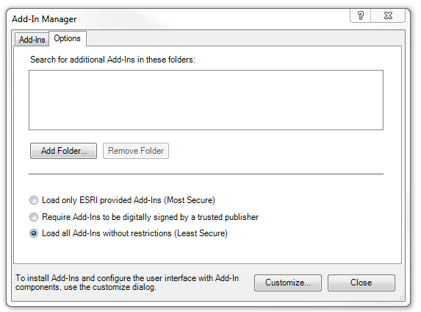

*Add-In Manager, Options tab*.

* 1. Click <*Add Folder...*>. Browse to the folder where the Add-In file is located and click <*OK*>.  
       
      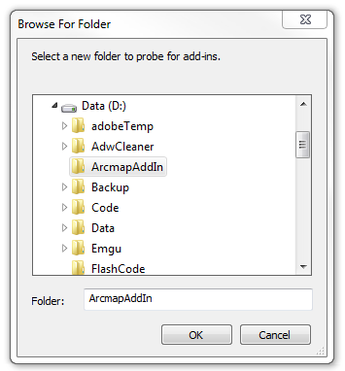

*Browse to the folder where the Add-In file is located.*

* 1. Close the Add-In Manager and restart ArcMap.
  2. Select menu: *Customize* ► *Add-In Manager*.
  3. Check whether Street Smart for ArcMap is ‘*Authenticated’*. If the Add-In is ‘*Untrusted’*, close the Add-In Manager, close ArcMap and install the certificate ‘thawte-intermediate-ca.cer’ first (which is made available together with this user manual).

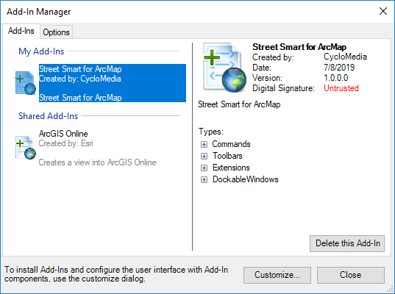

*Add-In Manager, Add-Ins tab, check if Street Smart for ArcMap is ‘Authenticated’ or ‘Untrusted’.*

* 1. To install the certificate, please perform the following steps:
     1. Double-click on ‘thawte-intermediate-ca.cer’ to install the certificate.  
          
         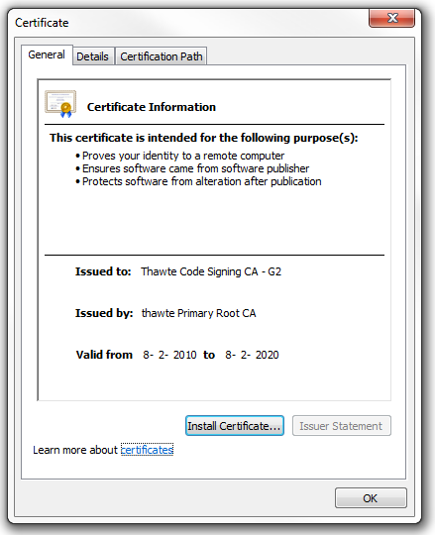

*Install the certificate.*

* + 1. Click on <*Install Certificate...*> to start the installation wizard for the certificate.   
         
       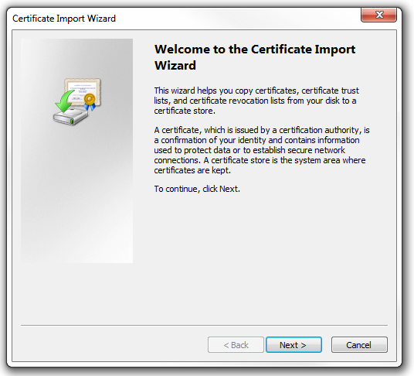

*Certificate Import Wizard.*

* + 1. Click: <*Next*>, <*Next*>, <*Finished*> to complete the installation of the certificate.  
         
        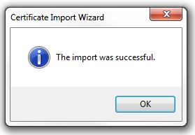

*The certificate is successfully imported.*

* 1. Start ArcMap.
  2. Select menu: *Customize* ► *Add-In Manager*.
  3. Check if Street Smart for ArcMap is now ‘Authenticated’. You can then proceed to paragraph 2).   
       
     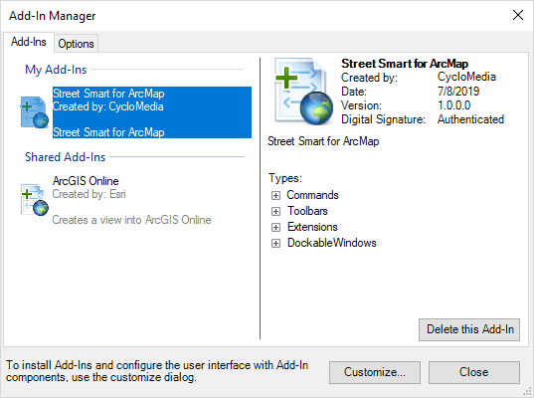

*Add-In Manager, Add-Ins tab, check that Street Smart for ArcMap is now ‘Authenticated’.*

1. If you start ArcMap for the first time after installing the Add-In, you will be shown the agreement form. Mark ‘*I have read and agree to the terms of use*’ as checked and click <*OK*>.  
   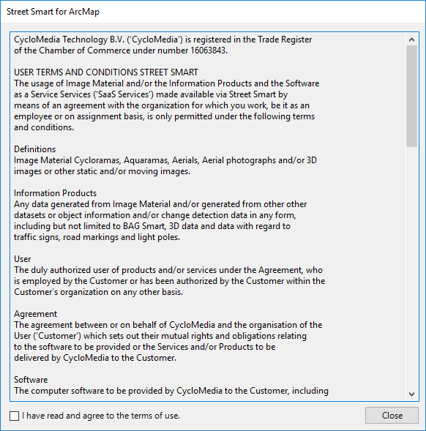

*Agreement form.*

1. If you do not get the agreement form, select menu: *Customize* ► *Extensions*.
2. Mark the extension *Street Smart for ArcMap* as checked. You will now get the agreement form (you will get this agreement form only once). Agree to the terms of use and click <*OK*>.  
     
   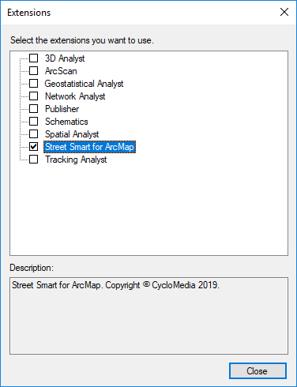

*Extensions window, select the extension Street Smart for ArcMap.*

1. Close the extensions window.
2. Open the Street Smart toolbar: *Customize* ► *Toolbars* ► *Street Smart*.
3. On the *Street Smart for ArcMap* toolbar, click the *Open* *Street Smart Options* button.

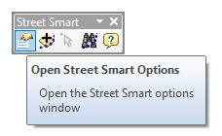

*The selected Open Street Smart Options icon.*

1. Select the tab *Configuration*.
2. If you use a proxy server, you can enable *Use a proxy server* and enter the data about your proxy server. If you are not sure whether your organization uses a proxy server, you can check in your web browser proxy settings or contact your IT department.  
    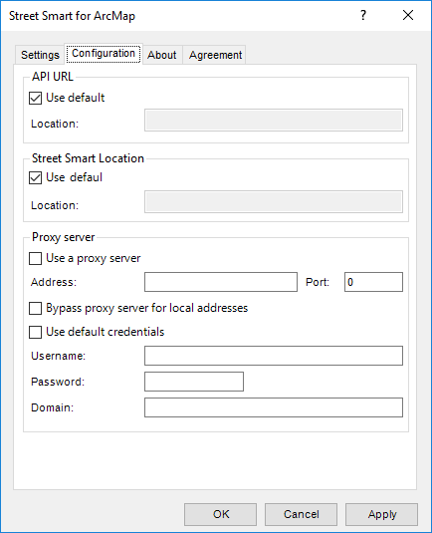

*Street Smart for ArcMap Add-In window, Configuration tab.*

1. Most organizations access Street Smart from the Azure cloud. If your organization accesses Street Smart from local servers, uncheck the API URL and the Street Smart location *Use default* option and enter the correct URLs at *Location* instead.
2. Select the *Settings* tab.

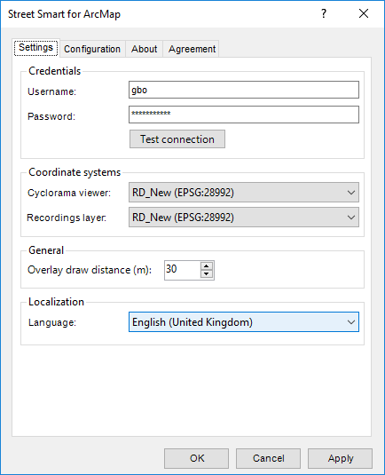

*Street Smart for ArcMap Add-In window, Settings tab.*

1. Enter your username and password and press: <*Test connection*>. If you see the message ‘*Login Successful*’, you are logged in successfully.
2. Select the coordinate system which the viewer(s) should use.
3. Select the coordinate system which the recordings layer should use.
4. Press <*Apply*> for the changes to take effect. You are now ready to use *Street Smart for ArcMap*.

# How to use Street Smart for ArcMap

## Exploring and viewing Cycloramas in ArcMap

### How to show recent recording locations of Cycloramas

1. Select *Add Recent Cyclorama Layer* in the Street Smart toolbar.   
     
   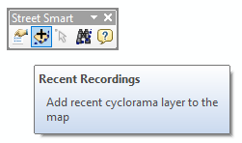

*The selected Add Recent Cyclorama Layer icon.*

1. In the *Table Of Contents* of ArcMap a new layer will appear as shown in the figure below. Zoom in on the map to a zoom level of at least 1:2000 to see the recording locations on the map (provided there are recordings in the area).  
     
    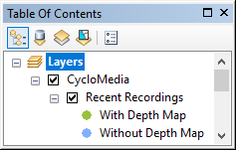

*The layer with recent recordings in the Table Of Contents.*

### How to open Cycloramas

1. Select *Open the location in a cyclorama* in the Street Smart toolbar.   
   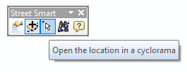

*The selected Open the location in a cyclorama icon*.

1. Click on a dot for the corresponding Cyclorama to open in a Cyclorama viewer. Shift-Click on another dot and a second Cyclorama will open.   
     
   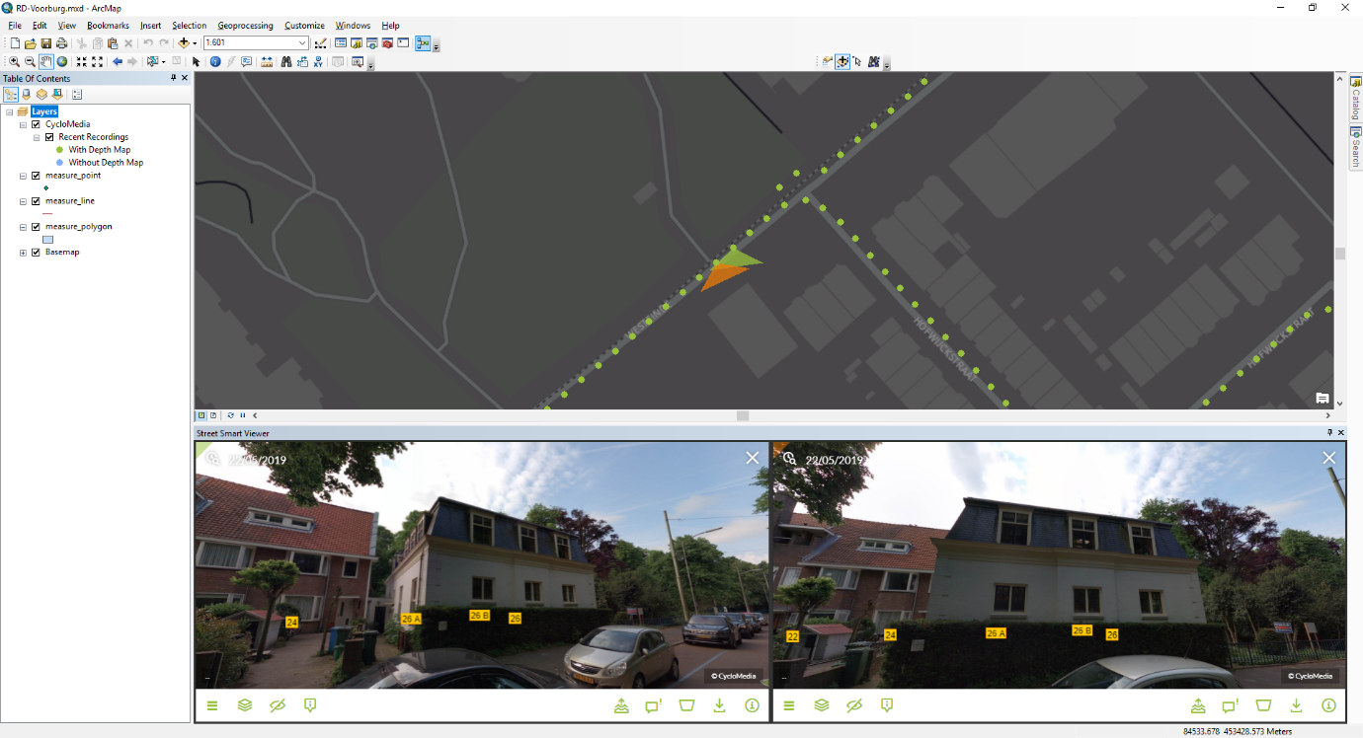

*Street Smart for ArcMap with two Cyclorama viewers opened.*

### How to open historical recording locations

1. Click on the historical Cyclorama slider in the Cyclorama. Select an older image. See the image below.

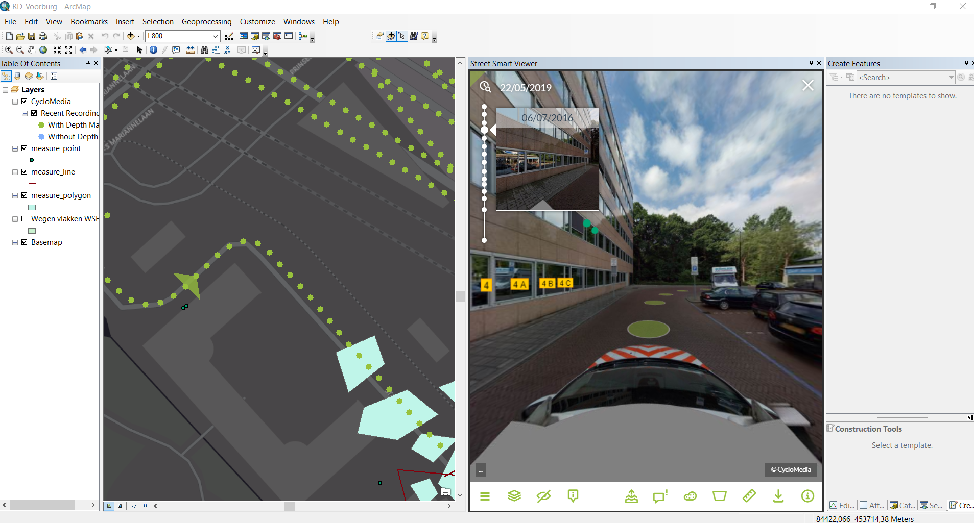

*Cyclorama with an open historical cyclorama Slider*

1. After a historical image has been selected, the recording locations of that year are visible. See the image below.

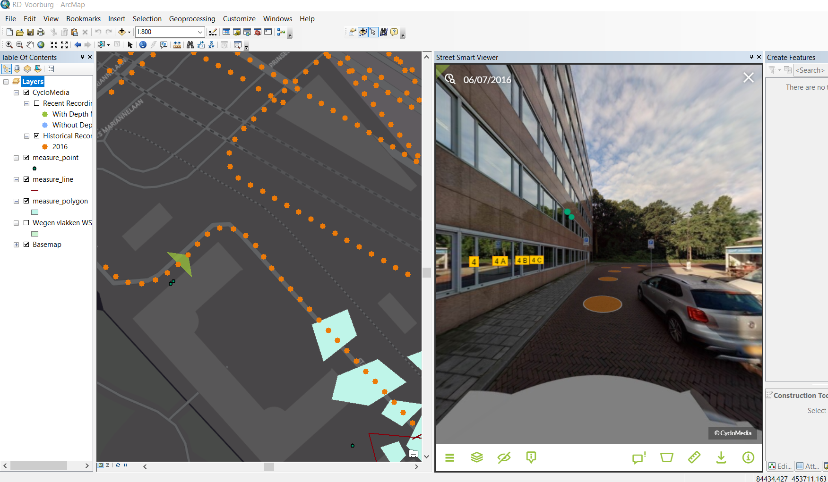

*Map with historical recordings*

1. Now other recordings can be clicked. Those recordings are then opened.

## How to show vector data in Cycloramas

1. Add one of the various types of vector data to the Table Of Contents, such as:
   * Shapefiles
   * ArcSDE
   * Personal MDB
   * File GDB
2. The data must be in the same coordinate system as set for the Cyclorama viewer and should be enabled to store Z data. If the feature class is not Z-enabled, the data draws at ground level.
3. Open a Cyclorama. Click on *Overlays*, then check the box in the Cyclorama viewer. Note that the vector data will now be shown in the Cycloramas.  
   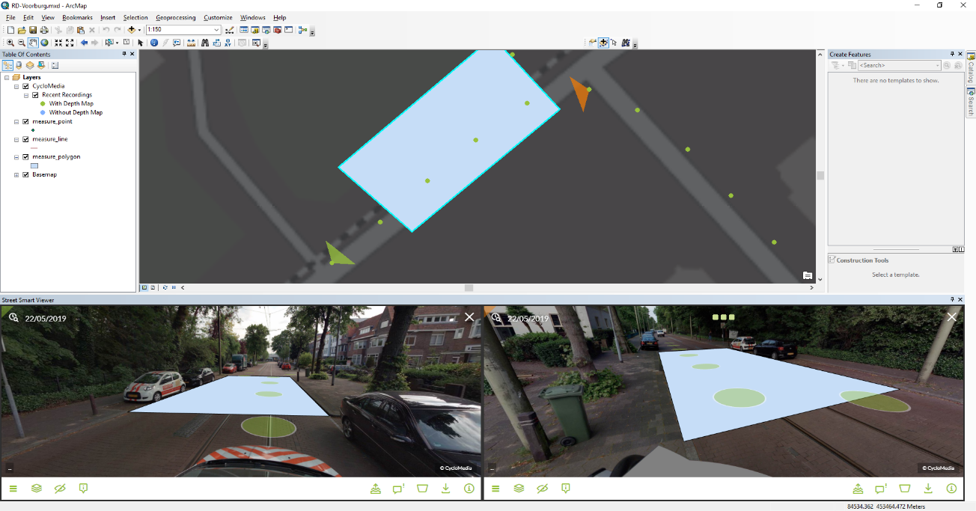

*Showing vector data as overlay in the Cyclorama viewers.*

1. Optionally, set the distance at which vector layer data is displayed in the *Settings* tab of the *Street Smart for ArcMap* window with the option *Overlay draw distance[m]*. The default overlay draw distance is 30 meters if your coordinate system uses meters and 98 feet if it uses feet. This means only vector data located within 30 meters (or 98 feet) of the recording location will be displayed.

## Performing measurements to Add Features

Measurements are stored in vector data layers. Point, line or surface measurements each are stored in separate point, line or polygon vector data layers. The following sections explain in detail how to perform the various types of measurements.

### Measure Smart measurement – point measurement

1. Add a point vector data layer to the map to store the measurement(s).
2. Open a Cyclorama in which the object to be measured is clearly visible.
3. Right-click on the vector layer and select: *Edit Features* ► *Start Editing* to start editing mode in ArcMap.
4. Select the point vector layer in the *Create Features* window to start a point measurement.
5. Notice *that Measure Smart* is enabled in the *Street Smart for ArcMap* window.  
     
   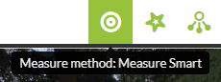

*Enable Smart Click measurements.*

1. Select the point you want to measure in the Cyclorama.

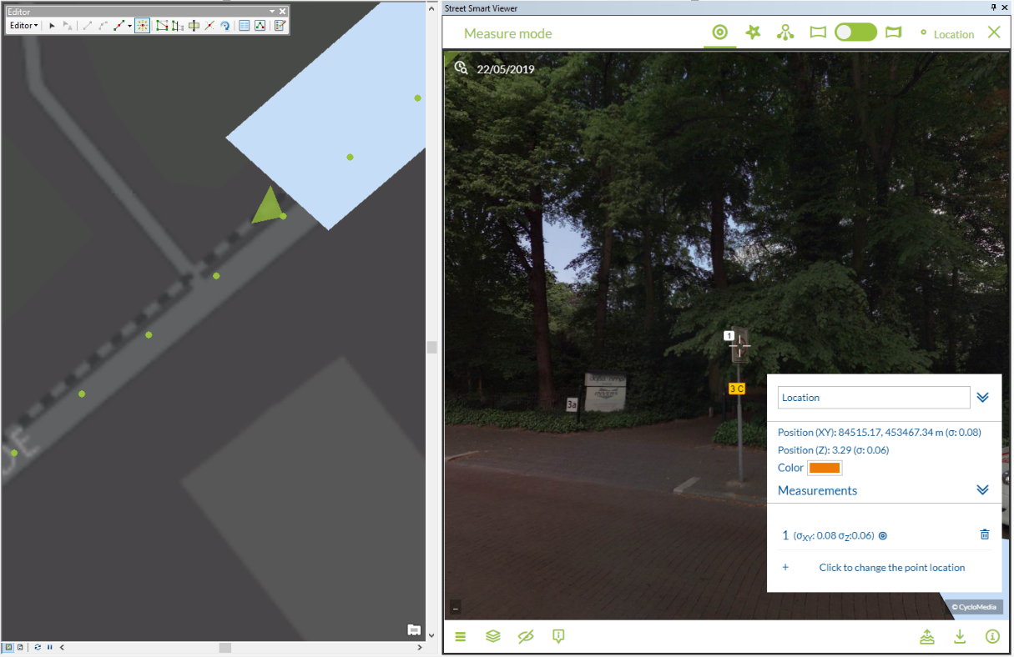

*Point measurement (with Measure Smart).*

1. The *Measurement Information* window will now show information about the measurement.
2. Complete measurement by clicking the new measurement button (the one that says Location) at the top of the Street Smart Viewer window.
3. Repeat steps 6 & 8 to add another point.
4. If you are finished with your measurements, save the edits to the vector layer in the *Editor* toolbar in ArcMap.

### Measure Smart measurement – line / surface measurement

1. Add a line or a polygon vector data layer to the map to store the measurement(s).
2. Open a Cyclorama in which the object to be measured is clearly visible.
3. Right-click on the vector layer and select: *Edit Features* ► *Start Editing* to start editing mode in ArcMap.
4. Select the line or polygon layer in the *Create Features* window to start a line or a surface measurement.
5. Select the first point you want to measure in the Cyclorama.

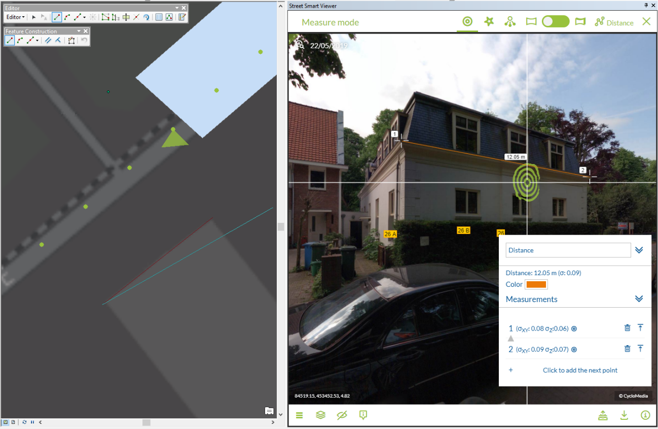

*Line or polygon measurement after adding the first point.*

1. The *Measurement Information Panel* will now show information about the measurement.
2. To add more measurement points, close the current point and add subsequent points by repeating steps 6, and 7.
3. Click on the *Finish Sketch* button on the *Feature Construction* toolbar to close the measurement.

If you are finished with your measurements, save the edits to the vector layer in the *Editor* toolbar in ArcMap.

### Forward Intersection measurement – point measurement

1. Add a point vector data layer to the map to store the measurement(s).
2. Open a Cyclorama in which the object to measure is clearly visible.
3. Right-click on the point vector layer and select: *Edit Features* ► *Start Editing* to start editing mode in ArcMap.

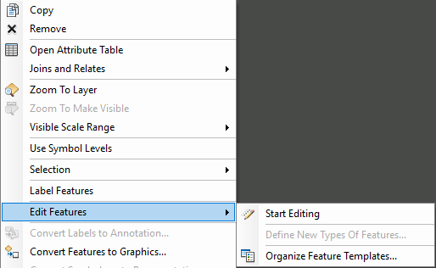

*Start editing mode in the newly added vector layer.*

1. Select the point layer in the *Create Features* window to start a point measurement.

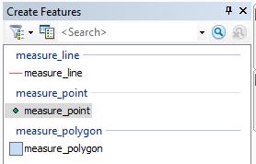

*The Create Features window with several vector layers.*

1. For Forward Intersection measurements, enable Forward Intersection measurements in the *Street Smart for ArcMap* window.  
   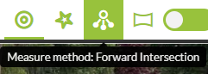

*If necessary, enable Forward Intersection measurements.*

1. Select the point you want to measure in the first Cyclorama. 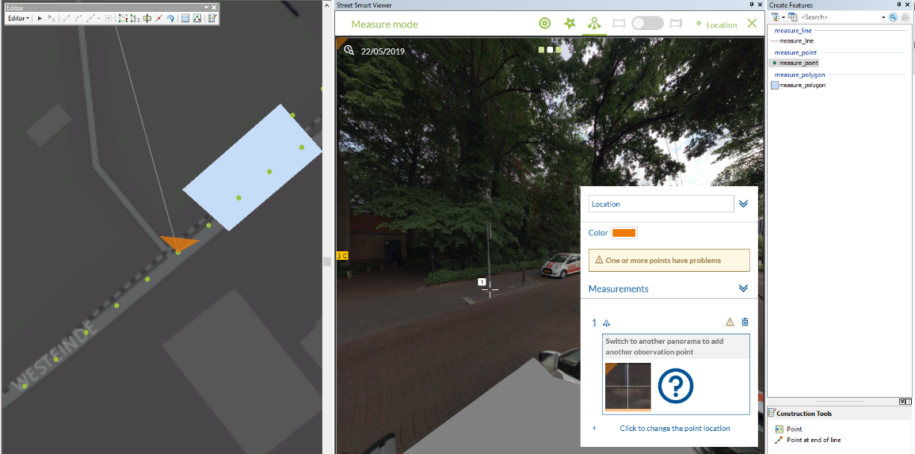
2. Select the same point in another Cyclorama.  
   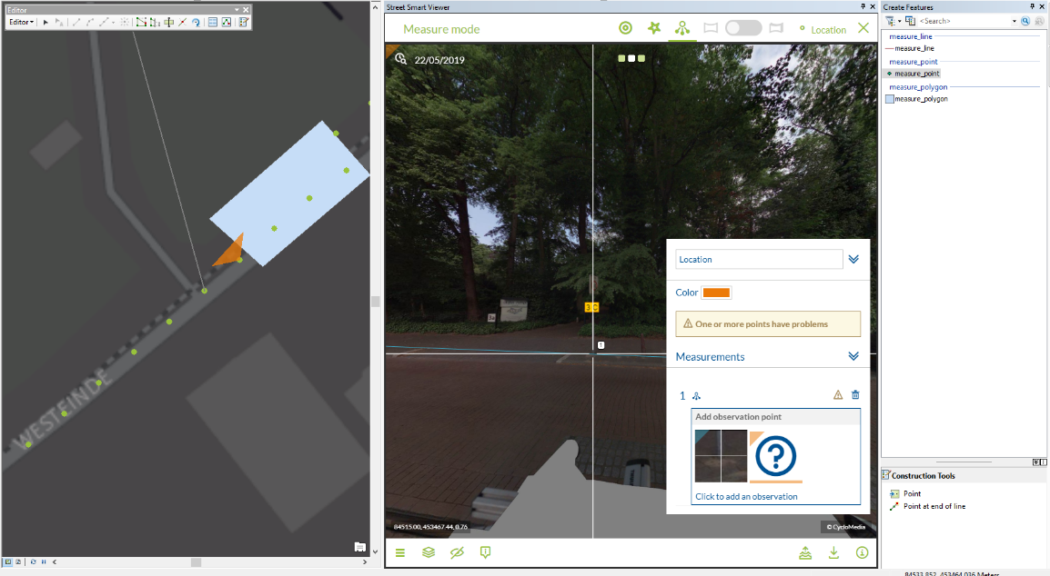

*Performing a point measurement (without Smart Click).*

1. If you are finished with your measurements, save the edits to the vector layer in the *Editor* toolbar in ArcMap, as shown in the figure below.   
     
   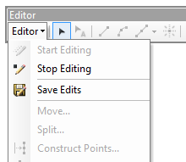

*Editor toolbar in ArcMap to save edits and to start and stop editing.*

### Forward Intersection measurement – line / surface measurement

1. Add a line or a polygon vector data layer to the map to store the measurement(s).
2. Open a Cyclorama in which the object to measure is clearly visible.
3. Right-click on the vector layer and select: *Edit Features* ► *Start Editing* to start editing mode in ArcMap.
4. Select the line or polygon layer in the *Create Features* window to start a line or a surface measurement.
5. For Forward Intersection measurements, enable Forward Intersection measurements in the *Street Smart for ArcMap* window.



*Enable Forward Intersection measurements.*

1. Select the first point you want to measure in the first Cyclorama.
2. Then select the second and subsequent points you want to measure, until you have selected all the points you want to measure in the first Cyclorama.   
   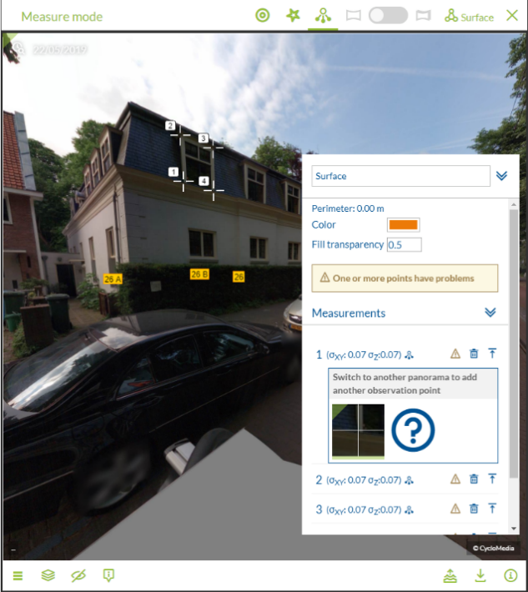

*Select all the points in the first Cyclorama step by step.*

1. Repeat the selection of points in the other Cyclorama(s) and make sure you select them in the same order as with the first Cyclorama.
2. The measurement is now complete. If you want to edit some measurement points you can add or remove observation points. Move through the measurement points by clicking on the number.
3. Click on the *Finish Sketch* button on the *Feature Construction* toolbar to close the measurement.  
   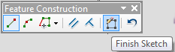

*Use Finish Sketch on the Feature Construction toolbar to close the measurement.*

1. If you are finished with your measurements, save the edits to the vector layer in the *Editor* Toolbar in ArcMap.  
     
   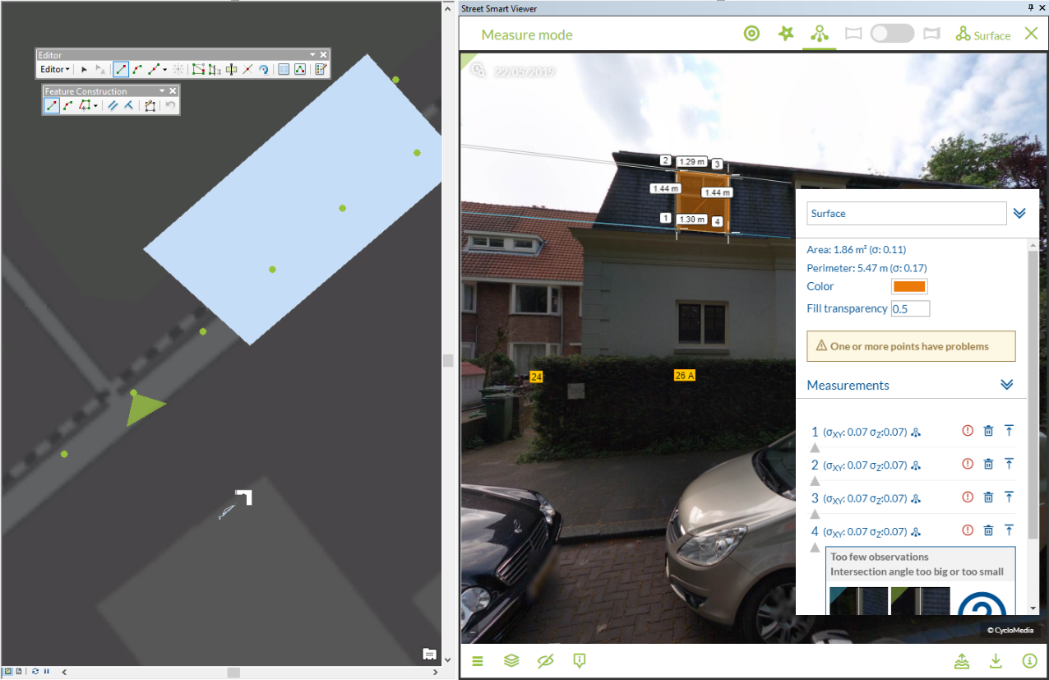

*After selecting the points in the second Cyclorama, the measurement is complete.*

### Smart Click measurement – point measurement

1. Add a point vector data layer to the map to store the measurement(s).
2. Open a Cyclorama in which the object to be measured is clearly visible.
3. Right-click on the vector layer and select: *Edit Features* ► *Start Editing* to start editing mode in ArcMap.
4. Select the point vector layer in the *Create Features* window to start a point measurement.
5. Enable Smart Click measurements in the *Street Smart for ArcMap* window.  
     
   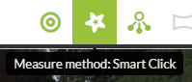

*Enable Smart Click measurements.*

1. Select the point you want to measure in the Cyclorama.

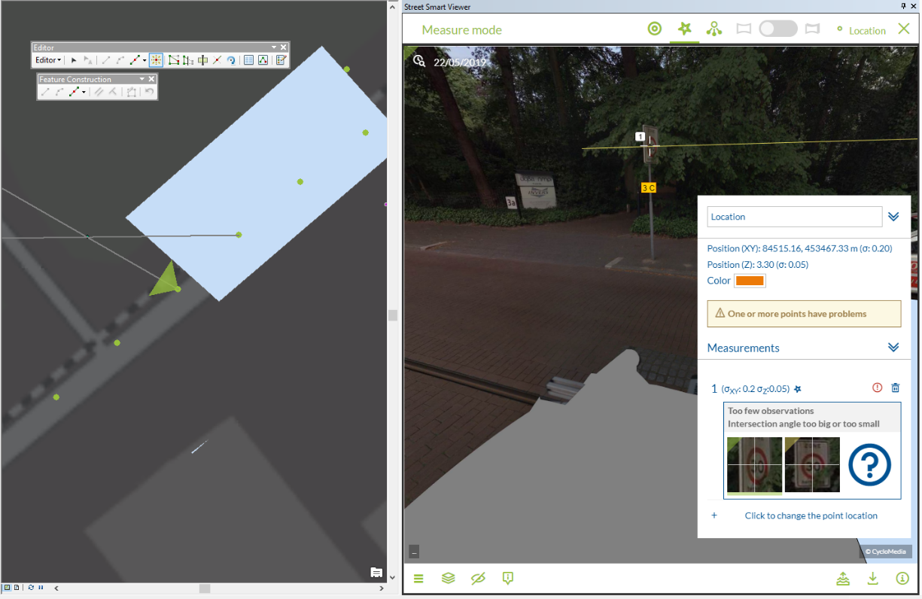

*Point measurement (with Smart Click).*

1. The *Measurement Information* window will now show information about the measurement.
2. You can also add or remove observation points if you switch the edit mode to Forward Intersection. If you want to add more observation points, open a new Cyclorama and select the point you want to measure.
3. If you are finished with your measurements, save the edits to the vector layer in the *Editor* toolbar in ArcMap.

### Smart Click measurement – line / surface measurement

1. Add a line or a polygon vector data layer to the map to store the measurement(s).
2. Open a Cyclorama in which the object to be measured is clearly visible.
3. Enable Smart Click measurements in the *Street Smart for ArcMap* window.
4. Right-click on the vector layer and select: *Edit Features* ► *Start Editing* to start editing mode in ArcMap.
5. Select the line or polygon layer in the *Create Features* window to start a line or a surface measurement.
6. Select the first point you want to measure in the Cyclorama.

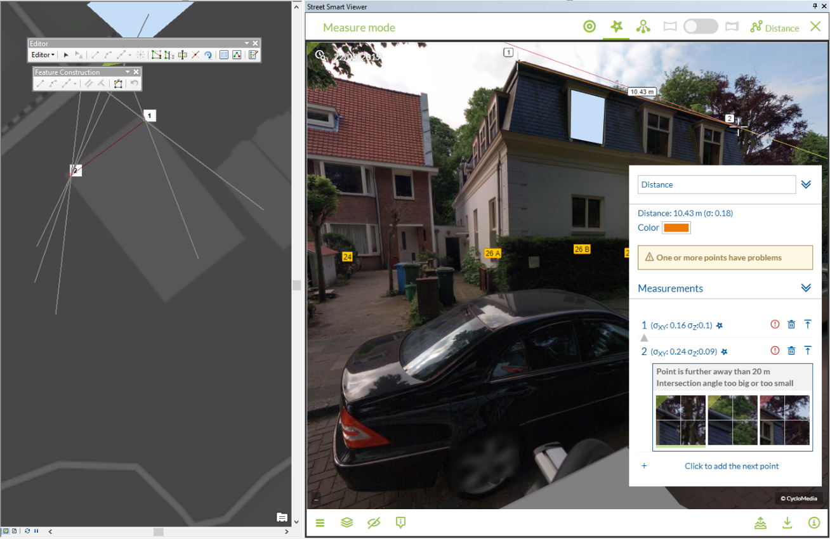

*Line or polygon measurement after adding the first point.*

1. The *Measurement Information Panel* will now show information about the measurement.
2. If you want to edit or check some observation points, click the point number first.
3. You can check the other Cycloramas in which Smart Click found the object by clicking the point line and by clicking on the observation image. You can also add or remove observation points. If you want to add more observation points, open a new Cyclorama and select the point you want to measure.
4. To add more measurement points, close the current point and add subsequent points by repeating steps 6, 7, 8 and 9. It is recommended to check all Smart Click measurement points.
5. Click on the *Finish Sketch* button on the *Feature Construction* toolbar to close the measurement.
6. If you are finished with your measurements, save the edits to the vector layer in the *Editor* toolbar in ArcMap.

### How to open a measurement for editing

1. Select the *Edit Tool* in the *Editor* toolbar and start editing.
2. Select a feature on the map to open the measurement for editing in the Cyclorama.  
     
   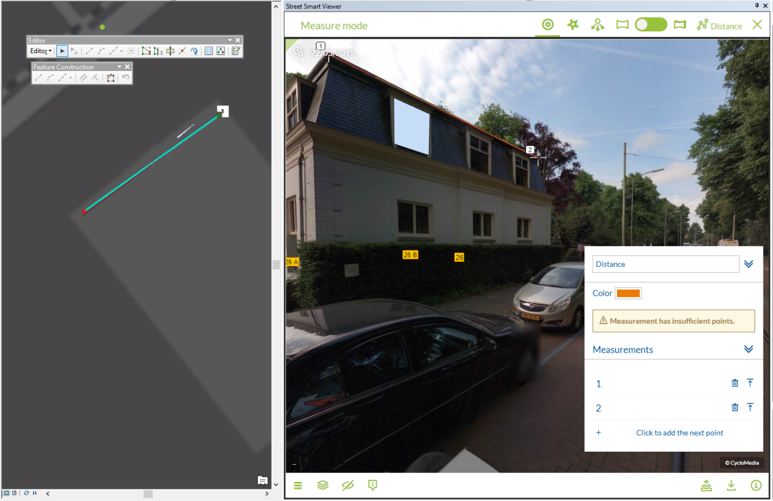

*Edit Tool in the Editor toolbar and measurement shown in Cyclorama*

1. It is now possible to edit the measurement in the Cyclorama or on the map.
2. If you want to edit a measurement point in the Cyclorama, select that point in the map.
3. Use the *Sketch Properties* button in the *Editor* toolbar to view the values of the measurement points.   
     
   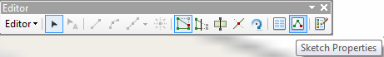

*Sketch Properties in the Editor toolbar.*

### How to measure without adding a feature

1. Click the *Start measuring* button.

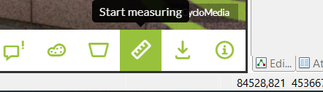

*Toolbar with the selected start measuring button.*

1. Select the preferred type of measurement.

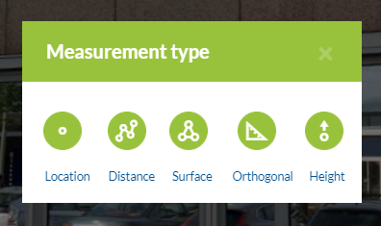

*The measurement type selection box.*

1. Now it is possible to measure without storing the features in a layer.

## Cyclorama search functionality

1. To start the Cyclorama search functionality, click on the *Search by Image ID* button in the Street Smart toolbar.

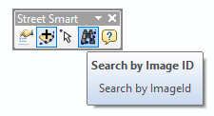

*Search by Image ID icon in the Street Smart toolbar*

1. You will now see the Cyclorama search window.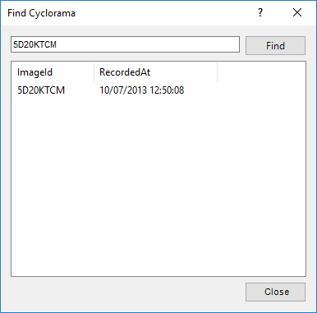

*Find Cyclorama window*

1. Enter an Image ID and press the *Find* button.
2. After a few seconds you will get the results
3. Double-click a result to go to the cyclorama.

